



**Software Project Management Course Design**

|  |  |
| --- | --- |
| **Design Topic：** | **Enchanted Movie iOS App Design And Development** |
| **Group Member：** | **202230310259 Xu Mengmeng** |
|  | **202230310231 Wang Simin** |
|  | **202230310215 Qu Ruyun** |
| **Tutor：** | **Liu Jin** |

**2022.03**

**TABLE OF CONTENTS**

**Chapter 01 *INTRODUCTION*** 4

**Chapter 02 *PROJECT SCOPE MANAGEMENT*** 5

THE IMPORTANCE OF PROJECT SCOPE MANAGEMENT 5

SCOPE PLANNING 5

SCOPE DEFINITION 6

TECHNICAL PROCESS 6

RESOURCE REQUIREMENTS 7

CHANGE MANAGEMENT PLAN 7

**Chapter 03 *PROJECT ORGNIZATION MANAGEMENT*** 8

THE IMPORTANCE OF PROJECT ORGNIZATION MANAGEMENT 8

STAFFING MANAGEMENT PLAN 8

PROJECT MANAGEMENT APPROACH 9

**Chapter 04 *PROJECT SCHEDULES MANAGEMENT*** 10

THE IMPORTANCE OF PROJECT SCHEDULES 10

SCHEDULE BASELINE AND WORK BREAKDOWN STRUCTURE 10

MILESTONE LIST 11

TASK DECOMPOSITION AND TIME MANAGEMENT 12

**Chapter 05 *RISK MANAGEMENT*** 14

THE IMPORTANCE OF PROJECT RISK MANAGEMENT 14

RISK MANAGEMENT PLAN 14

**Chapter 06 *QUALITY MANAGEMENT*** 17

THE IMPORTANCE OF PROJECT QUALITY MANAGEMENT 17

QUALITY MANAGEMENT PLAN 17

**Chapter *07 COMMUNICATIONS MANAGEMENT*** 19

THE IMPORTANCE OF PROJECT COMMUNICATIONS MANAGEMENT 19

COMMUNICATIONS MANAGEMENT PLAN 19

**Chapter 08 *PROJECT COST MANAGEMENT*** 22

THE IMPORTANCE OF PROJECT PROCUREMENT MANAGEMENT 22

COST ESTIMATION 22

COST BUDGET 23

COST CONTROL 23

##### Chapter 01 INTRODUCTION

Enchanted Movie is a multifaceted iOS movie application that combines movie viewing, ticket booking, information browsing, and community interaction in one convenient platform. It is dedicated to delivering a superb movie experience for enthusiasts while staying ahead in the ever-changing cultural and commercial landscape. By blending cutting-edge technology and personalized design, Enchanted Movie offers users a range of functions and experiences, including:

* Sleek and user-friendly interface: The user interface should be visually appealing, easy to navigate, and provide various categories and search functions for users to quickly find their desired movies.
* Social features: Allow users to follow and interact with other users, share their viewing history and ratings, and recommend movies to friends.
* Custom playlists: Enable users to create their own playlists, save their favorite movies, and watch them later.
* User reviews: Let users rate and comment on movies, allowing other users to view and benefit from their opinions.
* Viewing history: Keep track of users' viewing history, making it easy for them to find recently watched movies.
* Search function: Allow users to search by keywords such as actors, directors, and movie titles.
* Movie information: Offer movie-related news, reviews, and box office rankings to keep users updated on the latest in the movie world.
* Review community: Build a community where movie enthusiasts can share their opinions and ideas with like-minded individuals.
* Movie ticketing: Provide online ticket purchasing functions, allowing users to easily check movie schedules and buy tickets without leaving the app.
* Daily recommendations: Offer a new movie recommendation to users every day, giving them the opportunity to discover new movies and broaden their viewing experience.

##### Chapter 02 PROJECT SCOPE MANAGEMENT

###### THE IMPORTANCE OF PROJECT SCOPE MANAGEMENT

Project scope management is a crucial aspect of project management, as it ensures that projects can achieve their expected goals on time. Through scope management, the project manager can ensure that project goals and requirements are clear and precise, avoiding scope creep and unnecessary changes. Additionally, scope management helps the project manager to clarify project tasks, assign them to suitable team members, and specify the resources required to complete them. During this process, the project manager can also manage project changes and determine their impact, ensuring that project schedules and budgets are not affected. Another critical role of scope management is to ensure that projects are delivered on time, meet customer expectations, and satisfy project budget and quality requirements. Ultimately, scope management can improve project performance by ensuring a shared understanding and expectation among the project team and stakeholders, reducing unnecessary scope changes and resource waste, and thereby increasing the project's success rate.

###### SCOPE PLANNING

This chapter aims to provide the scope and objectives of the Enchanted Movie application software project to ensure consistency in the team's understanding and expectations throughout the entire project process, while minimizing scope creep.

The Enchanted Movie project encompasses a range of activities, including requirements analysis, framework design, UI design, software functionality development, software functionality testing, and classroom demonstrations. The software will be designed to meet or exceed both organizational software standards and the additional requirements stipulated in the project charter.

The project also includes the creation of relevant documentation throughout the development process. The majority of the project's documentation is expected to be completed by the end of the second software iteration.

The project involves two source code inspections: the first inspection will verify the operation of the sub-functional modules, while the second inspection will evaluate the complete system's performance after the functional modules have been integrated. Upon completion of the inspections, the program source files must be submitted.

It's worth noting that this project is limited to the iOS system and does not entail any provisions for adaptability to other operating systems outside of iOS, nor for future software updates beyond the scope of the project.

###### SCOPE DEFINITION

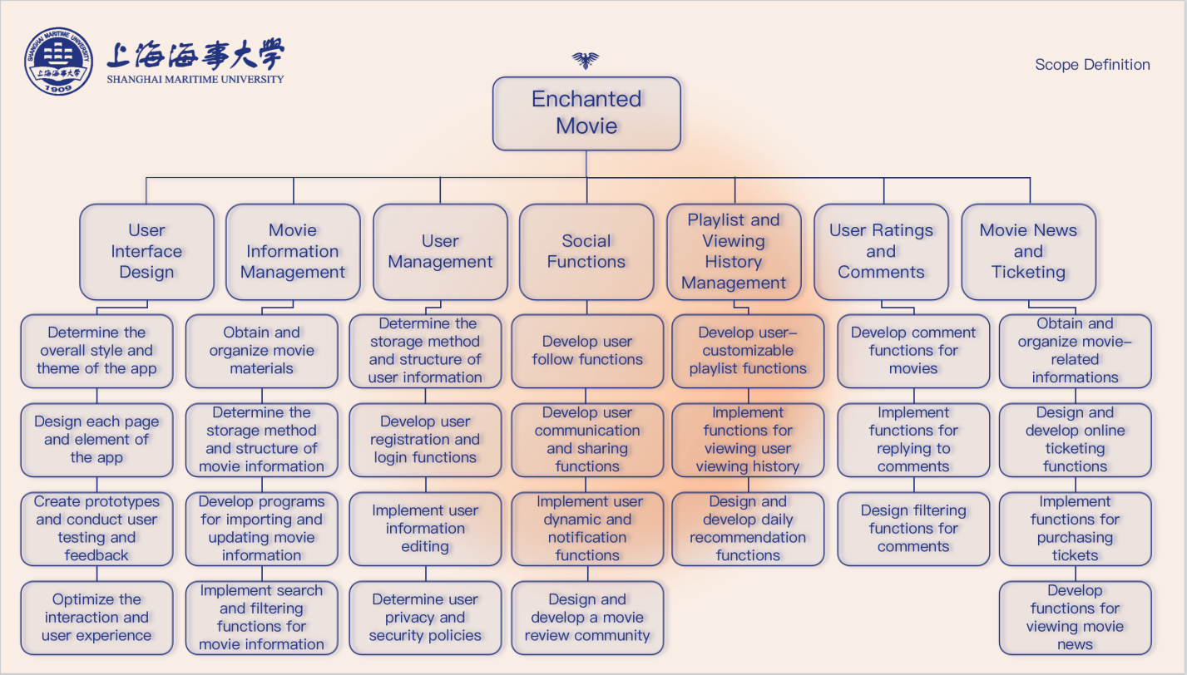

###### Fig.1: WBS task decomposition diagram

###### TECHNICAL PROCESS

The front-end interface of the application will be built using the SwiftUI framework based on the Swift programming language, and the back-end of the application will be built using the Django framework based on the Python programming language.

The project coding will adhere to a uniform indentation format, camel case naming convention, standardized comments, and code formatting.

Software testers are required to perform unit testing based on the provided testing documents.

The following documents are required to be delivered upon project completion:

* Software project management plan
* Requirements analysis report
* Design report
* Testing documents
* Other documents (As we need)

###### RESOURCE REQUIREMENTS

|  |  |
| --- | --- |
| Category | Resource Requirement |
| Front-end development tool | Xcode |
| Back-end development tool | Pycharm |
| Other development tools | Docker, Git |
| Collaboration platforms | Wolai, GitHub |
| Development devices | Two Windows PCs, one MacBook, and one CentOS7 server |
| Development location | The independent development location determined by the team |

###### Table 1: Resource requirements

###### CHANGE MANAGEMENT PLAN

The following steps outline the change control process for the Enchanted Movie project:

* Step 1: Requesters propose changes to the project manager by commenting on requirements in Wolai;
* Step 2: The project manager, along with other project team members and the requesters, assesses the impacts of the proposed changes on cost and risk;
* Step 3: Based on the assessment, the project manager makes a recommendation to the team;
* Step 4: The team decides whether to approve or reject the proposed changes based on the final assessment;
* Step 5: If the changes are approved by the team, the project manager implements them manually;
* Step 6: After any changes, it is ensured that they are communicated to the team and project stakeholders.

##### Chapter 03 PROJECT ORGNIZATION MANAGEMENT

###### THE IMPORTANCE OF PROJECT ORGNIZATION MANAGEMENT

Project organization management helps clarify each person's role and responsibility, ensuring that everyone is aware of their tasks and duties and preventing confusion and overlap. By implementing project organization management, resources such as personnel, materials, and finances can be allocated and utilized in a reasonable manner, maximizing resource utilization and cost control.

###### STAFFING MANAGEMENT PLAN

The Enchanted Movie project will be developed using a neural network-inspired structure, optimized through continuous internal interactions and feedback loops. This iterative process will refine the project's "coefficients" to achieve high efficiency with a small team, allowing for recursive management and parallel positions. The project will be managed by a team of three members, who will collaborate and work internally using the Wolai platform to assign responsibilities and complete all work.

The Enchanted Movie project team will require the following roles:

Project Manager (1 person): Responsible for overseeing all aspects of project management, including planning, creating, and managing work activities, tracking quality and risks, drafting reports, coordinating with team members, conducting performance evaluations, allocating resources, and participating in development and testing alongside the team. The Project Manager will also supervise a portion of the project's coding and programming tasks.

Backend Programmer and Risk Manager (1 person): Responsible for completing a portion of the backend coding tasks of the project and ensuring that functionality meets risk boundary standards. The Backend Programmer and Risk Manager will collaborate with the Project Manager to create risk reports, manage progress and risks, reduce risks, generate reports, and determine the impact of change requests.

Backend Programmer and Record Keeper (1 person): Responsible for completing a portion of the backend coding tasks of the project. All coding and programming tasks will be reviewed by the Project Manager before implementation. The Backend Programmer and Record Keeper will also compile all project documents and reports in an organized format, assist the Project Manager with configuration management and revision control of all project documents, sign responsibilities during all project meetings, and maintain a communication distribution list. This team member will be managed by the Project Manager and supervised by other team members. Performance feedback will be provided to the entire team via the Wolai platform.

Frontend Programmer and Quality Monitor (1 person): Responsible for UI design and frontend coding tasks of the project. All coding and programming tasks will be reviewed by the Project Manager before implementation. The Frontend Programmer and Quality Monitor will also assist with quality assurance, help the Project Manager establish quality control and assurance standards, and maintain quality control and assurance logs throughout the project.

All team members will be responsible for testing and utilizing testing software to establish Enchanted Movie testing specifications. The team will ensure all tests are complete and recorded according to testing software standards on the Wolai platform or GitHub. The Project Manager will be responsible for coordinating all testing resources. Team members will be managed by the Project Manager, and performance feedback will be provided to the entire team via the Wolai platform.

###### PROJECT MANAGEMENT APPROACH

The project team is composed of a project manager, a front-end developer, two back-end developers, a quality assurance personnel and a risk management. Xu Mengmeng is responsible for front-end development and quality assurance personnel, while Wang Simin and Qu Ruyun handle back-end development. In addition, Wang Simin also serves as the risk management personnel, while Qu Ruyun takes on the role of recorder.

The project manager role will be rotated among three individuals.

The project manager holds overall responsibility for managing and executing the project, with authority and accountability for monitoring project progress and communicating it with team members.

The project manager is in charge of handling all parent requirements, and will review and approve all sub-requirements and associated management plans. Team members have supervisory rights.

The project manager's authorization will be conducted on the Wolai platform used by the team. Regular meetings will be initiated by the project manager on Tencent Meeting.

Each team member must report project progress to the project manager and other team members throughout the project.

The project team members Wang Simin and Qu Ruyun will complete the overall framework design, while Xu Mengmeng will complete the UI design. The team members will develop the software's functionality according to their assigned tasks within the specified time frame.

##### Chapter 04 PROJECT SCHEDULES MANAGEMENT

###### THE IMPORTANCE OF PROJECT SCHEDULES

In software project management, effective schedule management is critical for success. Time is a limited resource, and whether a software project will be completed on time often depends on the team's ability to allocate and utilize time efficiently. To avoid problems such as delays, exceeding budgets, and low quality, it's essential to have a solid time management strategy in place, including detailed work plans, schedules, and identification of critical paths and milestones during the project planning phase. This helps team members understand project goals, division of labor, and time requirements, clarifying tasks and responsibilities. Progress control is also crucial to ensuring on-time project completion, with continuous monitoring during the implementation phase to promptly detect and resolve issues such as schedule variances and delays. By making timely schedule adjustments, the project can progress smoothly, avoiding disruptions to timeline and quality.

###### SCHEDULE BASELINE AND WORK BREAKDOWN STRUCTURE

The Work Breakdown Structure (WBS) of the Enchanted Movie project is developed based on the specific workload on the Wolai platform to establish the schedule baseline and work breakdown structure. The development time is scheduled for at least one hour per day per week based on the workload of team members to increase the effectiveness of meeting the deadline. Through close collaboration among project team members and research on past projects, a work system has been developed based on workload that matches the course load of team members.

Throughout the entire project lifecycle, there are two iterative processes to refine the work schedule to prevent progress completion from falling short or exceeding expectations. The specific time details are reflected in the iteration and requirements details, which are reviewed by the project manager and approved by the team members. If it is possible that the established boundary control may be exceeded, a change request will be submitted to the team leader. The team will assess the impact of changes on progress, cost, resources, scope, and risks. If it is determined that the impact will exceed the boundary conditions, the time boundary will be adjusted accordingly.

###### MILESTONE LIST

The chart below presents the major milestones and their respective schedule for the Enchanted Movie project. It is important to note that this chart solely encompasses the parent requirement milestones, such as requirements gathering and design or coding phases.

However, there may be additional, smaller milestones that are not included in the table but can be found in the sub-requirement details available on the shared collaboration platform.

In the event of any scheduling delays that could impact the milestones or delivery dates, the project manager and all team members must be informed immediately to take proactive measures and reduce any possible delays. Any changes approved for these milestones or dates will be communicated to the project team by the project manager.

Table 2: Milestones list

|  |  |  |
| --- | --- | --- |
| Milestone | Description | Date |
| Topic selection | Based on the level of demand for application software in various fields among the public, a questionnaire will be selected and a topic will be determined | 2023.03.01 |
| Requirement  Formulation | The requirements for Enchanted Movie will be based on design and will maximize feasibility | 2023.03.08 |
| Software Design | The frontend UI and theoretical functionality of the software will be designed | 2023.03.14 |
| Project Coding | Software Coding：  - FE page construction: 04.01-05.04  - BE function development：04.05-05.04  - FE and BE integration：05.05-05.10 | 2023.04.01 |
| Software Testing | The functionality of the software will be tested for completeness, and any related errors will be identified and corrected | 2023.05.10 |
| Project Optimization | Based on the results of testing, the project's functionality will be optimized and performance improved | 2023.05.15 |

###### TASK DECOMPOSITION AND TIME MANAGEMENT

Each member of the Enchanted Movie project will work as a code engineer, collaborating on front-end and back-end development, testing, and documentation writing. The project manager will assign sub-requirements and manage parent requirements. Each team member will develop and process each sub-requirement and document their respective tasks according to the requirements. Each team member will be fully responsible for developing a task module assigned to them, and the project manager will review the collection of all modules.

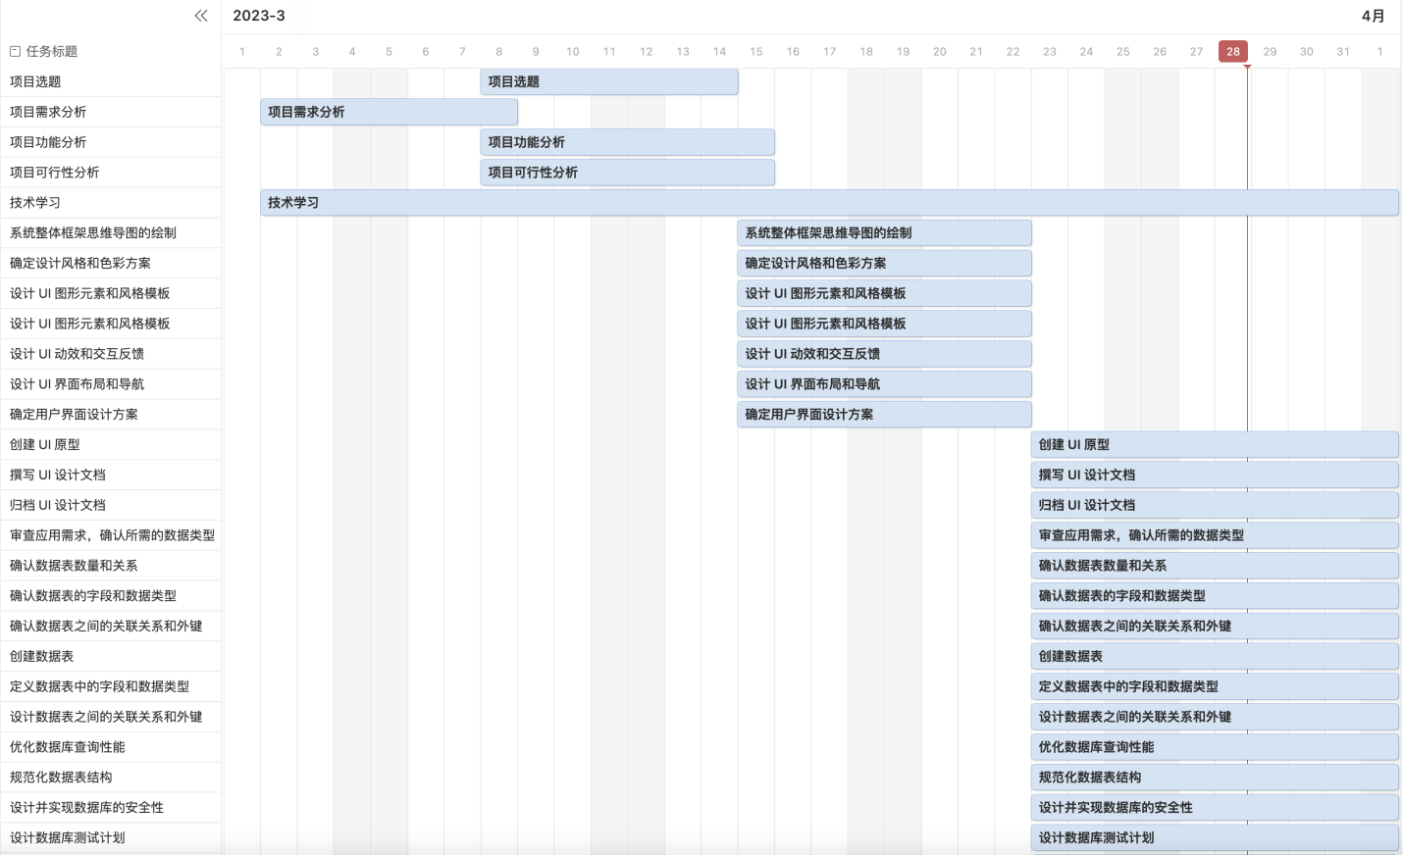

###### Fig.2: Schedule Gantt chart

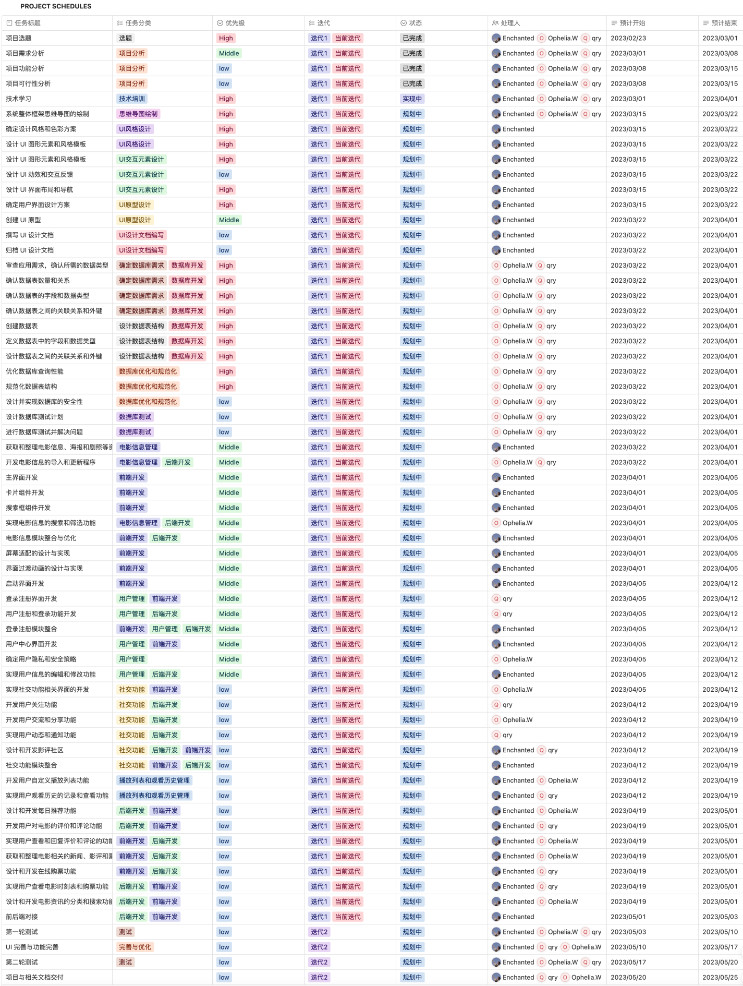

Fig.3: Schedule management

##### Chapter 05 RISK MANAGEMENT

###### THE IMPORTANCE OF PROJECT RISK MANAGEMENT

Project risk management is the art and science of identifying, analyzing, and responding to risk throughout the life of a project and in the best interests of meeting project objectives. A frequently overlooked aspect of project management, risk management can often result in significant improvements in the ultimate success of projects. Risk management can have a positive impact on selecting projects, determining their scope, and developing realistic schedules and cost estimates. It helps project stakeholders understand the nature of the project, involves team members in defining strengths and weaknesses, and helps to integrate the other project management knowledge areas.

###### RISK MANAGEMENT PLAN

The risk management approach for the Enchanted Movie project involves a systematic process where the project team identifies, rates, and prioritizes various risks. Every effort will be made to identify risks in advance, so that mitigation strategies can be implemented at the start of the project. The most likely and high-impact risks will be added to the project plan to ensure that designated risk management personnel take necessary steps to implement mitigation measures during the planning period. Wang Simin, the risk management personnel, will provide status updates on their assigned risks at weekly team meetings and promptly escalate any high-level risks for timely avoidance.

After the completion of the Enchanted Movie project, during the closing process, the project manager will analyze each risk and the risk management process. Based on this analysis, the project manager will work with the risk inspection personnel to determine any improvements that can be made to the risk management process for future projects and document them in a risk report. These improvements will be part of the lessons learned knowledge base and will be included in documents on the Wolai platform, which is semi-open to all members.

Additionally, we will conduct a comprehensive risk assessment and develop a robust risk management plan for potential risks that Enchanted Movie may face. Our evaluation will cover six key aspects, including risk categories, probability, impact level, risk description, prevention measures, and corrective measures. By assessing each risk category thoroughly, we can identify and evaluate potential risks that may impact the project's timeline, budget, and overall success. Please refer to the table below for more details:

|  |  |  |  |  |  |
| --- | --- | --- | --- | --- | --- |
| Risk Category | Probability | Impact | Risk Description | Preventive Measures | Corrective Measures |
| Personnel Risk | Medium | Medium | A core team member may temporarily leave the project due to health reasons. | Establish a multi-level team cross-training mechanism to ensure that multiple team members can take over the core member's responsibilities. | Prepare backup personnel for the core member to ensure that core functions can continue when necessary. |
| Technical Risk | High | High | The development team may encounter technical difficulties due to the use of new technology. | Establish a technical group including external team members to be able to solve problems quickly when they arise. | Regularly schedule technical reviews to ensure the project is on schedule, and adjust technical solutions if necessary. |
| Schedule Risk | High | High | The project may face delays due to personnel changes or technological reasons. | Establish an executable timetable so that everyone knows the deadline for their tasks. | Regularly evaluate progress and find solutions to ensure that the project can proceed as planned. |
| Requirement Risk | Medium | High | Frequent changes in requirements may result in project delays or exceed budgets. | Develop a clear requirement change process, clarify the person responsible for the change, and ensure that each change is sufficiently approved and evaluated. | Review changes to avoid unnecessary changes, and timely incorporate necessary changes into the project management plan, and conduct sufficient communication and coordination to avoid unnecessary delays and additional costs. |
| Financial Risk | Low | Low | The project may face financial problems due to insufficient funds or budget overruns. | Regularly monitor the budget and seek ways to reduce costs. | Regularly conduct budget reviews and take corrective action when necessary. |
| Management Risk | Low | High | In the project management process, improper management decisions or lack of resources, communication, and leadership abilities may lead to project progress being blocked or major errors occurring. This may ultimately result in project delays, cost overruns, or quality issues, leading to project failure. | Provide sufficient resources and power for the project manager to effectively manage and control project progress, cost, and quality; establish effective communication mechanisms and processes to ensure smooth communication between project team members. | Strengthen communication and coordination in the event of management errors; seek support and solutions in the event of resource shortages; adjust plans and resources promptly to ensure project progress and completion quality in the event of schedule delays; take cost-saving measures promptly in the event of cost overruns, such as optimizing resource utilization and improving workflow. |

##### Table 3: Risk management plan

##### Chapter 06 QUALITY MANAGEMENT

###### THE IMPORTANCE OF PROJECT QUALITY MANAGEMENT

Quality management is a critical process in software project management that ensures that the products or services delivered during software development meet expected quality standards. Its importance in software project management lies in the following benefits:

* Quality management ensures that products meet customer requirements, thus achieving customer satisfaction. Through comprehensive evaluation and testing, software products or services can be tailored to meet customer needs and expectations.
* Quality management improves the quality of software products or services, ensuring they meet high-quality standards and comply with all relevant industry regulations. It enables the detection and resolution of issues that arise during software development, and best practices can be implemented to improve the quality and reliability of software products.
* Quality management reduces costs by identifying and correcting issues early in the software development process, thereby reducing the cost of fixing issues later. By lowering the number of defects and improving software maintainability, quality management can lower the overall cost of software projects.

###### QUALITY MANAGEMENT PLAN

The Enchanted Movie project team is committed to ensuring high-quality work, with Xu Mengmeng as the primary person in charge of quality inspection. All team members are responsible for completing their work to the appropriate quality level, from individual work packages to the final project delivery. The quality inspection personnel oversee the overall supervision and management of quality.

The Enchanted Movie project has the following quality roles and responsibilities:

* The project manager approves all quality standards for the project, reviews project tasks and deliverables, and ensures that they meet approved quality standards. The project manager also signs off on the final acceptance of project deliverables.
* Along with the project manager, quality inspection personnel Xu Mengmeng are responsible for the overall quality management of the project. They implement the quality management plan, ensure that all tasks, processes, and documents conform to the plan, and work with the project team to establish acceptable quality standards. The project manager communicates and tracks all quality standards in real-time.
* The quality inspection personnel recommend tools and methods for tracking quality and standards and create and maintain quality control and assurance logs for the entire project.
* The project team and stakeholders assist the project manager and quality inspection personnel in establishing acceptable quality standards and communicate any concerns about quality to the project manager.

The Enchanted Movie project's quality control uses tools and methods to ensure that all project deliverables meet approved quality standards. To meet the requirements and expectations of deliverables, a formal process is implemented to measure and accept quality standards. The project manager ensures that all quality standards and quality control activities for the entire project are met. The quality inspection personnel verify that each deliverable meets all quality standards. If any changes to quality standards are proposed and approved, the project manager communicates these changes to the project team and updates all project plans and documents.

Quality assurance ensures that all processes used in completing the project meet acceptable quality standards, designed to maximize project efficiency and minimize waste. For each process used throughout the project, the project manager, with the assistance of the quality inspection personnel, tracks and measures quality according to approved standards and ensures that all quality standards are met.

##### Chapter 07 COMMUNICATIONS MANAGEMENT

###### THE IMPORTANCE OF PROJECT COMMUNICATIONS MANAGEMENT

Effective communication is crucial to ensuring the success of a project, and project management communication plays a vital role in achieving this. By facilitating clear and open communication between project stakeholders and teams, project managers can improve mutual understanding and collaboration, coordinate the work of team members, solve problems, and make decisions that ensure the project is completed as planned.

Moreover, project management communication helps to ensure the transparency and controllability of the project, by providing timely and accurate information on project progress and risks to stakeholders and team members, which helps them better understand the project status and strengthens control and supervision. Additionally, good communication can enhance the predictability of the project, enabling team members to plan and adjust their work better in response to project progress and changes. Therefore, project management communication is an indispensable component of project management and is crucial to the project's success.

###### COMMUNICATIONS MANAGEMENT PLAN

This communication management plan establishes a framework for communication throughout the project. It will serve as a comprehensive guide and will be updated as communication needs evolve. The plan defines the roles of Enchanted Movie project team members in relation to communication and includes a communication matrix that outlines the project's communication requirements and behaviors such as meetings and other forms of communication. Additionally, the plan provides a project team directory containing contact information for all stakeholders directly involved in the project.

The project manager assumes a leadership role in ensuring effective communication throughout the project. Specific communication needs are outlined in the communication matrix below, which will guide what information to communicate, who is responsible for communicating it, when to communicate, and with whom. Refer to the communication management details table below for further information.

|  |  |  |  |  |  |  |
| --- | --- | --- | --- | --- | --- | --- |
| Communication Type | Description | Frequency | Format | Participants/Distribution | Deliverable | Owner |
| Weekly Status Update | Summarizes project status in Wolai | Weekly | Wolai | Project team | Status report | Project Manager |
| Team Meeting | Records progress and team reports on Tencent Meeting | Weekly | Tencent Meeting | Project team | Meeting presentation | Project Manager |
| Iteration Review | Reviews iteration progress and provides feedback in Wolai | End of each iteration (2 iterations in total) | Wolai | Project team | Iteration document | Project Manager |
| Monthly Review | Evaluates stage progress and plans for the next stage | Monthly | Wolai | Project team | Completion report | Project Manager |
| Technical Design Review | Reviews technical and design aspects as per requirements | As needed | Wolai | Project team | Online presentation | Project Manager |

Table 4: Communications plan

|  |  |  |
| --- | --- | --- |
| Name | Title | Wolai ID |
| Xu Mengmeng | Front-end Developer  Quality assurance personnel  (or Project Manager) | Enchanted |
| Wang SiMin | Back-end Developer  Risk management(or Project Manager) | Ophelia |
| Qu Ruyun | Back-end Developer Recorder  (or Project Manager) | qry |

Table 5: Communication list

|  |  |
| --- | --- |
| Communication Method | Description |
| Tencent Meeting | The project manager schedules meetings in advance using the Tencent Meeting app, and sets group announcements to remind team members to attend. Permissions are set during the meeting and the content is recorded for subsequent review. After the meeting, the recorder uploads the meeting minutes to the meeting document on the Wolai platform. |
| Wolai | Wolai provides a short communication service for team members to discuss project requirements. Topics should be closely related to the requirements and provide solutions. The format should be clear and complete, and members should not change the comments of other members without permission. If changes are necessary, team members and project managers must be informed, and the project manager must monitor the progress of the discussion. |
| WeChat | The format can be flexible. If there are any special questions or requests related to the project, team members can "@" the project manager in Wolai. |

Table 6: Communication method

##### Chapter 08 PROJECT COST MANAGEMENT

###### THE IMPORTANCE OF PROJECT PROCUREMENT MANAGEMENT

Effective project cost management is essential for the success of any project. It involves the processes of estimating, allocating, and controlling the costs associated with a project. Improper management of project costs can lead to overspending, project delays, and even project failure.

Proper cost management ensures that the project is completed within the allocated budget, and resources are utilized efficiently. It also enables project managers to make informed decisions by providing them with accurate cost data. Additionally, it aids in identifying potential cost savings and cost overruns, which can be addressed before they become major issues.

Effective cost management also ensures that stakeholders are aware of the project's financial status, allowing them to make informed decisions and take necessary actions. It helps in building trust among stakeholders by demonstrating a commitment to transparency and accountability. In summary, effective project cost management is a critical component of project management that enables successful project completion within the allocated budget while promoting transparency and accountability.

###### COST ESTIMATION

Our team used a bottom-up approach to estimate the costs for this project. We estimated the cost of each individual task and then aggregated the costs to develop an overall cost estimate. Our cost estimation for this project is as follows:

Table 7: Cost estimation

|  |  |  |
| --- | --- | --- |
| Task | Duration (days) | Cost (RMB) |
| Requirements gathering | 5 | 2,500 |
| Design and development planning | 10 | 5,000 |
| Frontend development (Xu Mengmeng) | 60 | 20,000 |
| Backend development (Wang Simin) | 60 | 20,000 |
| Backend development (Qu Ruyun) | 60 | 20,000 |
| Testing and quality assurance | 10 | 5,000 |
| Deployment and release | 5 | 2,500 |
| Total | 60 | 75,000 |

###### COST BUDGET

Based on the above cost estimation, we have developed a budget for the project. The budget includes all the costs associated with the project, such as salaries, hardware, software, and other expenses.

Table 8: Cost budget

|  |  |  |
| --- | --- | --- |
| Expense Category | Estimated Cost (USD) | Expense Category |
| Salaries | 60,000 | Salaries |
| Hardware and software | 10,000 | Hardware and software |
| Other expenses | 24,000 | Other expenses |

###### COST CONTROL

To ensure that we stay within the allocated budget, we have developed a cost control plan, which includes the following steps:

1. Establishing a baseline: We will track the costs incurred during the initial stages of the project to establish a baseline. This will help us identify any cost overruns and take corrective action.

2. Regular monitoring: We will monitor the costs of the project regularly and compare them to the budget. This will allow us to identify any deviations from the budget and take corrective action.

3. Contingency planning: We will develop a contingency plan to deal with any unforeseen expenses that may arise during the project.

4. Change management: We will manage any changes to the project scope or requirements to ensure that they do not cause cost overruns.

5. Continuous improvement: We will continuously improve our cost estimation and cost control processes to ensure that we can deliver projects within the allocated budget.